**TASK 1**

//create database

CREATE DATABASE assignment;

// CREATE TABLE EMPLOYEE

CREATE TABLE employee(em_id int(20) AUTO_INCREMENT PRIMARY KEY , first_name varchar(50) not null , last_name varchar(50) not null , salary int(50) not null ,

joining_date datetime not null , department varchar(50) not null);

//INSERT EMPLOYEE DATA

INSERT INTO employee(em_id , first_name , last_name ,salary , joining_date, department ) VALUES ('1', 'JOHN' , 'ABRAHAM' ,'1000000', '2013-01-01' , 'BANKING');

INSERT INTO employee(em_id , first_name , last_name ,salary , joining_date, department ) VALUES ('2' , 'MICHAEL' , 'CLERK',

'800000' , '2013-01-01', 'INSURANCE' ) , ('3' ,'ROY' , 'THOMAS' , '700000' ,'2013-02-01', 'BANKING' ) ;

CREATE PROCEDURE INSERT_employee(

em_id int(20),

first_name varchar(50),

last_name varchar(50) ,

salary int(50),

joining_date datetime ,

department varchar(50))

BEGIN

INSERT INTO employee(em_id , first_name , last_name , salary , joining_date , department ) VALUES

(em_id , first_name , last_name , salary , joining_date , department );

END

CALL INSERT_employee( '4', 'TOM' , 'JOSE', '600000', '2013-02-01', 'INSURANCE') ;

CALL INSERT_employee( '5', 'JERRY' , 'PINTO', '650000', '2013-01-01', 'INSURANCE');

CALL INSERT_employee( '6', 'PHILIP' , 'MATHEW', '750000', '2013-01-01', 'SERVICES');

CALL INSERT_employee( '7', 'TESTNAME1' , '123', '650000', '2013-01-01', 'SERVICES');

CALL INSERT_employee( '8', 'TESTNAME2' , 'LNAME%', '600000', '2013-02-01', 'INSURANCE')

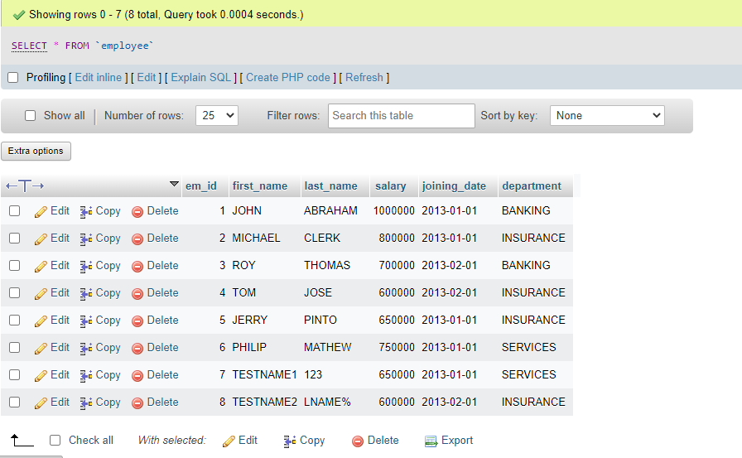

//CREATE TABLE INCENTIVES

CREATE TABLE incentives(incentive_id int(20) PRIMARY KEY AUTO_INCREMENT , employee_ref_id int(20) NOT null , incentive_date date not null ,

incentive_amt int(50) NOT null, FOREIGN KEY (employee_ref_id) REFERENCES employee(em_id));

//INSERT INCENTIVES DATA

CREATE PROCEDURE insert_incentives( IN incentive_id int(20), IN employee_ref_id int(20), IN incentive_date date, IN incentive_amt int(50) )

BEGIN

INSERT INTO incentives(incentive_id,employee_ref_id,incentive_date,incentive_amt)values(incentive_id,employee_ref_id,incentive_date,incentive_amt);

END//

CALL INSERT_incentives( '1', '1' , '2013-02-01','5000');

CALL INSERT_incentives( '2', '2' , '2013-02-01','3000');

CALL INSERT_incentives( '3', '3' , '2013-02-01','4000');

CALL INSERT_incentives( '4', '1' , '2013-01-01','4500');

CALL INSERT_incentives( '5', '2' , '2013-01-01','3500');

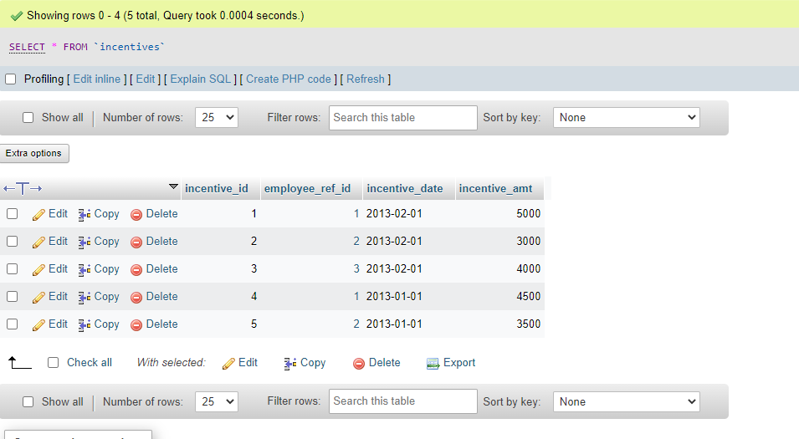

* **SQL Queries**

1. Get First_Name from employee table using alias name “Employee Name”.

SELECT first_name AS Employee_Name FROM employee;

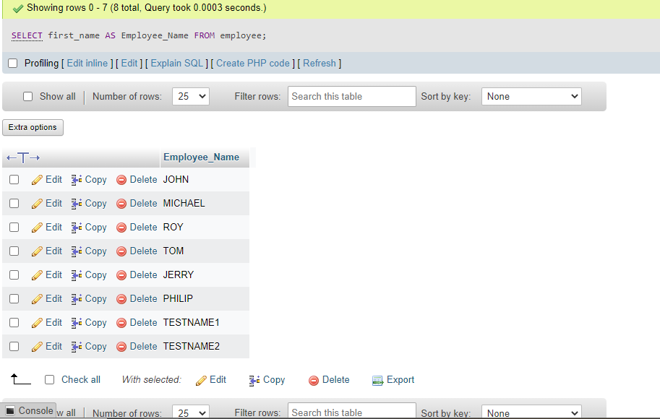

b) Get FIRST_NAME, Joining year, Joining Month and Joining Date from employee table.

SELECT first_name , joining_date FROM employee;

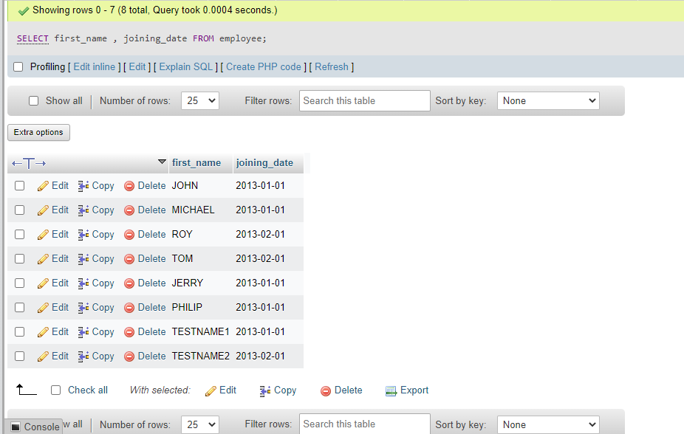

c) Get all employee details from the employee table order by First Name Ascending And Salary descending?

SELECT * FROM employee ORDER BY salary DESC;

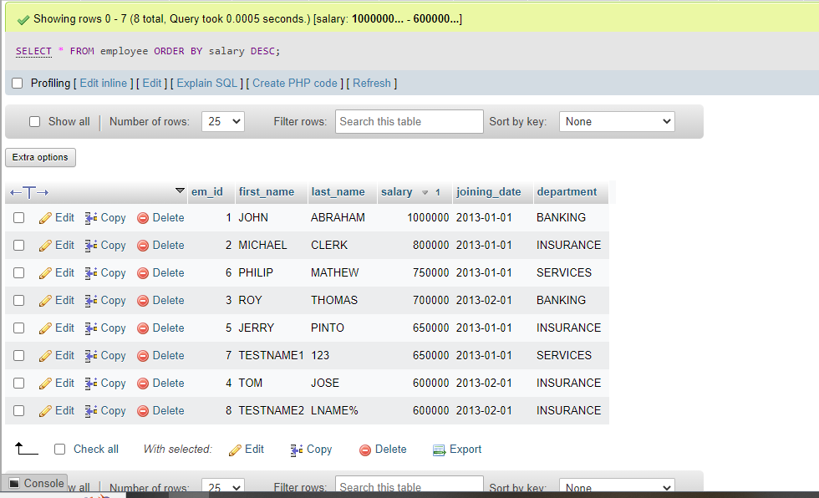

d)Get employee details from employee table whose first name contains „o‟.

SELECT * FROM employee

WHERE first_name LIKE '%o%';

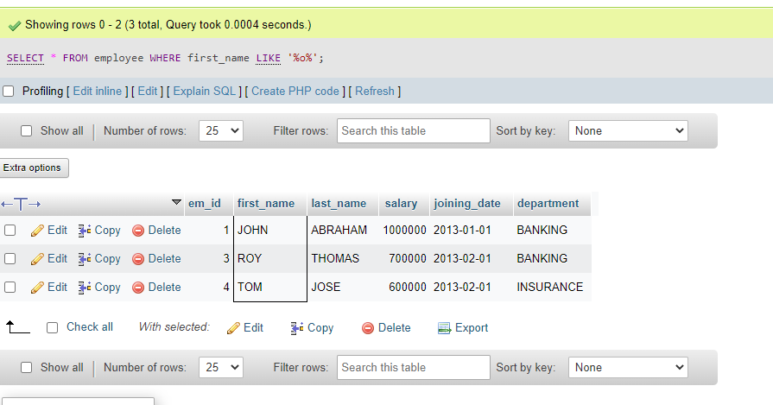

e)Get employee details from employee table whose joining month is “January”.

select * from employee WHERE DATE_FORMAT(joining_date,"%M")="January";

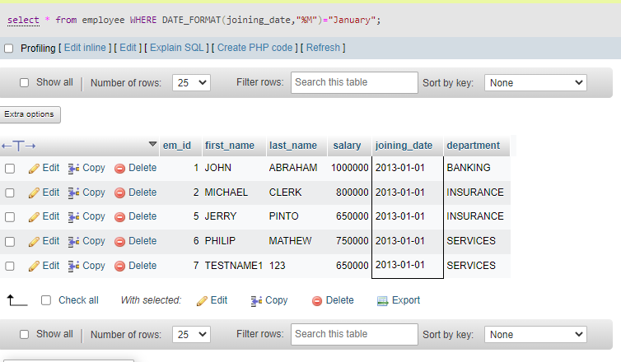

f)Get department, total salary with respect to a department from employee table Order By total salary descending.

SELECT department , SUM(salary) salary FROM employee GROUP BY department ORDER BY salary DESC;

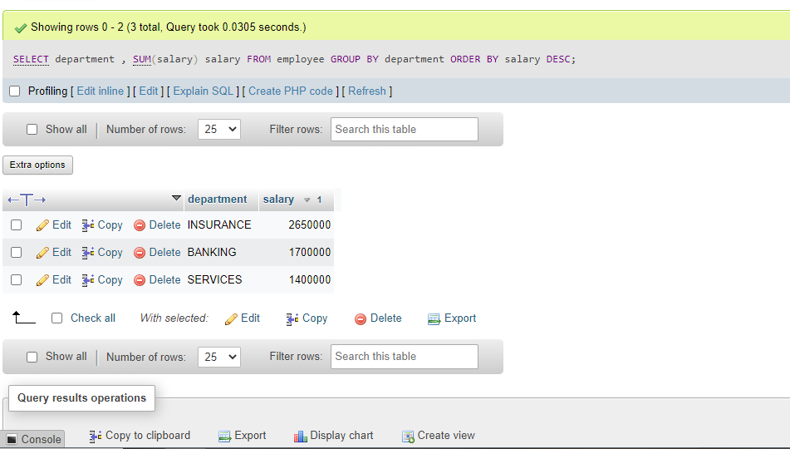

g)Get department wise maximum salary from employee table order by salary ascending?

SELECT department, MAX(salary) salary FROM employee GROUP BY department ORDER BY salary ASC;

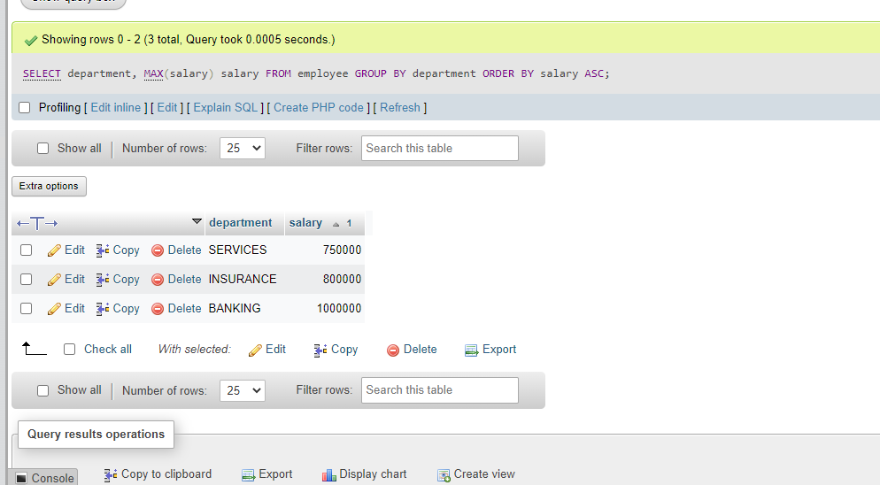

h)Select first_name, incentive amount from employee and incentives table for those Employees who have incentives and incentive amount greater than 3000

SELECT first_name , incentive_amt FROM employee A INNER JOIN incentives B ON A.em_id=B.employee_ref_id WHERE incentive_amt > 3000

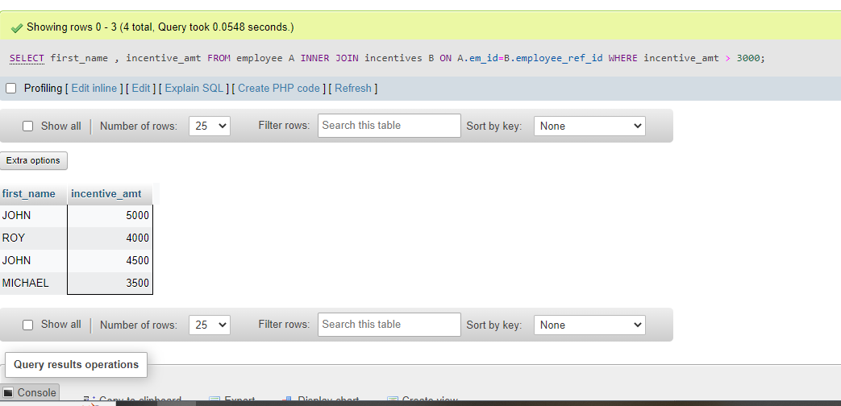

i) Select 2nd Highest salary from employee table.

SELECT * FROM employee GROUP BY salary ORDER BY salary desc limit 1,1;

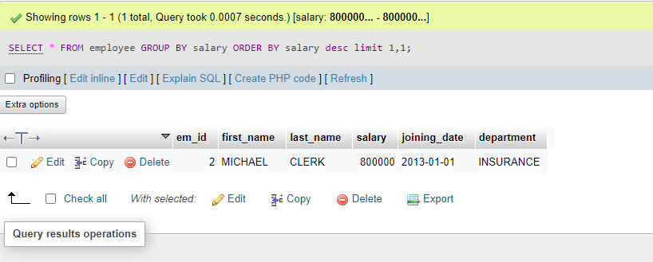

j)Select first_name, incentive amount from employee and incentives table for all Employees who got incentives using left join.

SELECT first_name , incentive_amt

FROM employee A INNER JOIN incentives B

ON A.em_id=B.employee_ref_id;

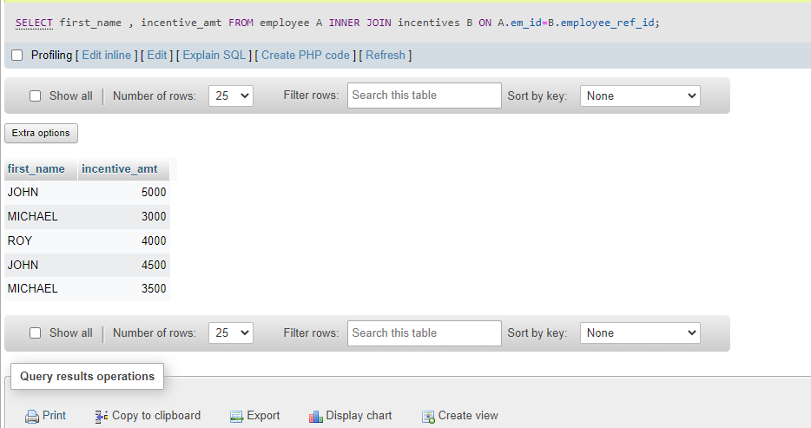

k)Create View OF Employee table in which store first name, last name and salary only.

CREATE VIEW employee_view AS SELECT first_name , last_name , salary FROM employee;

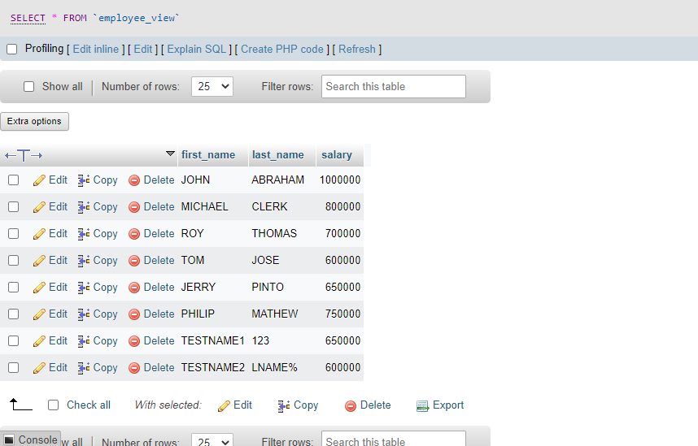

l) Create Procedure to find out department wise highest salary.

CREATE PROCEDURE insert_emp()

BEGIN

SELECT department, max(salary) FROM employee GROUP BY department;

END

CALL insert_emp();

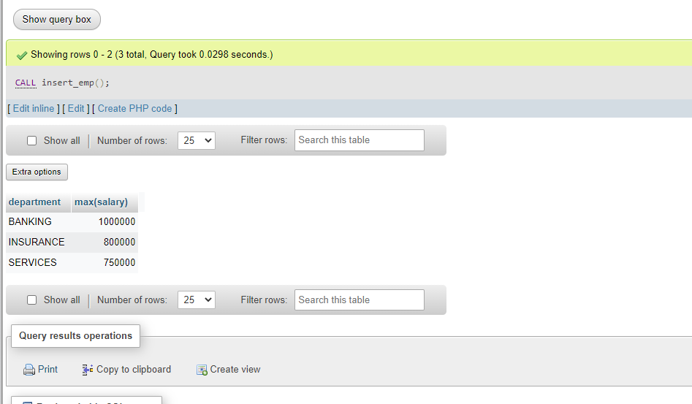

m) Create after Insert trigger on Employee table which insert records in view table.

CREATE TABLE reg_log(

reg_id int AUTO_INCREMENT PRIMARY KEY,

em_id int(20),

first_name varchar(50),

last_name varchar(50),

salary int(50),

modified_dt date,

CONSTRAINT PK_reg reg_id PRIMARY KEY(reg_id)

)

CREATE TRIGGER insert_trigger_employee AFTER INSERT ON employee FOR EACH ROW

BEGIN

INSERT INTO reg_log(em_id ,first_name,last_name ,salary,joining_date,department ,modified_dt )VALUES

(em_id ,first_name,last_name ,salary,joining_date,department ,modified_dt)

END